Requirements Analysis & System Design
Complete Use Case Diagrams and Analysis
System Overview
IoT-powered hydroponic system for growing leafy greens in South Africa, featuring automated nutrient delivery, environmental control, and remote monitoring via ESP32.
Actor Identification
Primary Actors | Secondary Actors
End User - Home grower using the system | Cloud Service - External IoT platform for data storage/processing
Mobile App User - User accessing system remotely | Alert System - Sends notifications
System Administrator - Advanced user/developer (you) | Plant Database - Stores plant-specific requirements
 | Calendar/Time Service - Provides scheduling functions

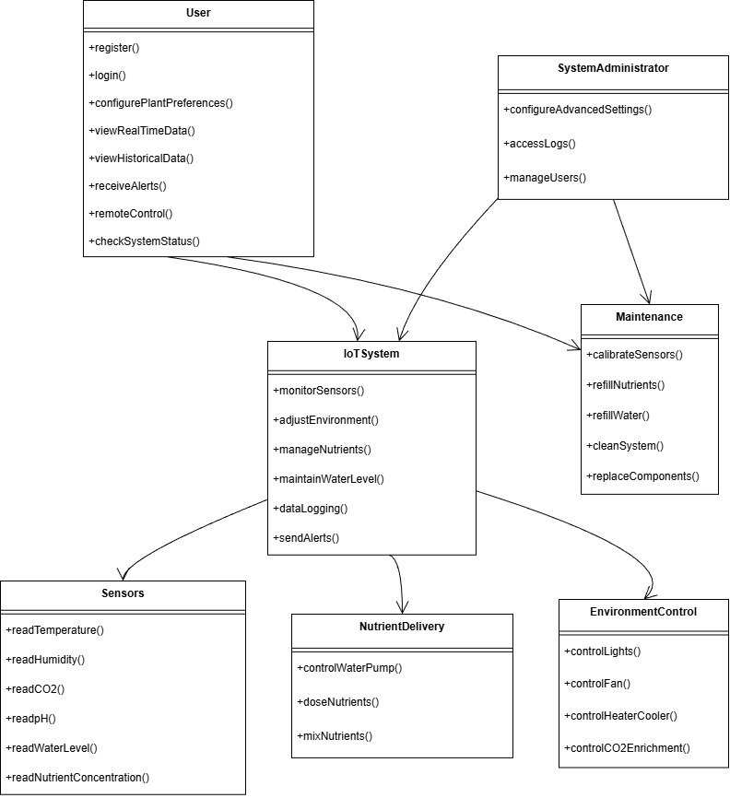
UC-1: Monitor Environmental Conditions
Primary Actors | Secondary Actors | Preconditions | Main Flow | Alternate Flow | Post Conditions
System (automated) | End User | System powered on, sensors calibrated | System continuously polls all sensors at 5-minute intervals | System detects sensor reading outside expected range | Environmental data stored and available for analysis
 |  |  | pH sensor measures nutrient solution acidity (target: 5.5-6.5 for leafy greens) | Marks sensor as "needs calibration"
 |  |  | Temperature sensor monitors water/reservoir temperature (target: 18-22°C) | Sends alert to user
 |  |  | Humidity sensor tracks ambient humidity (target: 40-60% for lettuce/spinach) | Continues operation with remaining sensors
 |  |  | CO2 sensor monitors CO2 levels (target: 400-800 ppm)
 |  |  | Water level sensor checks nutrient reservoir level

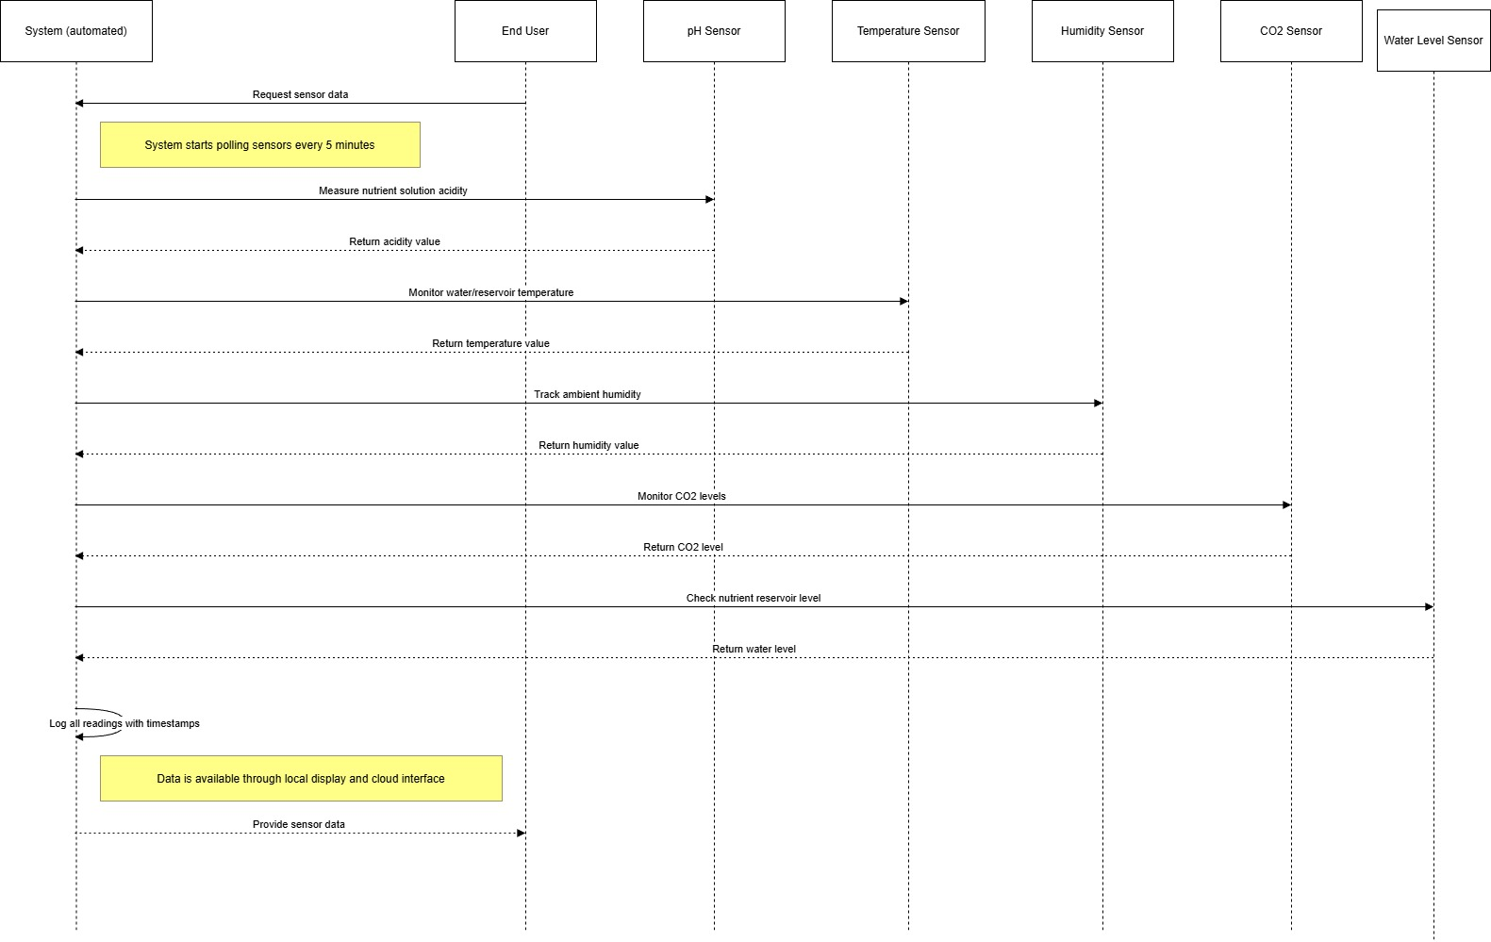
-

UC-2: Control Environmental Conditions
Primary Actors | Secondary Actors | Preconditions | Main Flow | Alternate Flow | Post Conditions
System (automated) | End User | Environmental parameter deviates from setpoint | System compares sensor readings with plant-specific targets | User remotely adjusts temperature setpoint | Environment maintained within target ranges
 |  |  | If temperature < 18°C), Activate nichrome wire heater via relay | System acknowledges override
 |  |  | If temperature > 22°C:  Activate axial fan for cooling | Operates according to manual settings
 |  |  | If temperature > 22°C: Activate axial fan for cooling
 |  |  | If humidity < 40%: Reduce fan speed
 |  |  | If CO2 < 400 ppm: Note for future CO2 enrichment capability

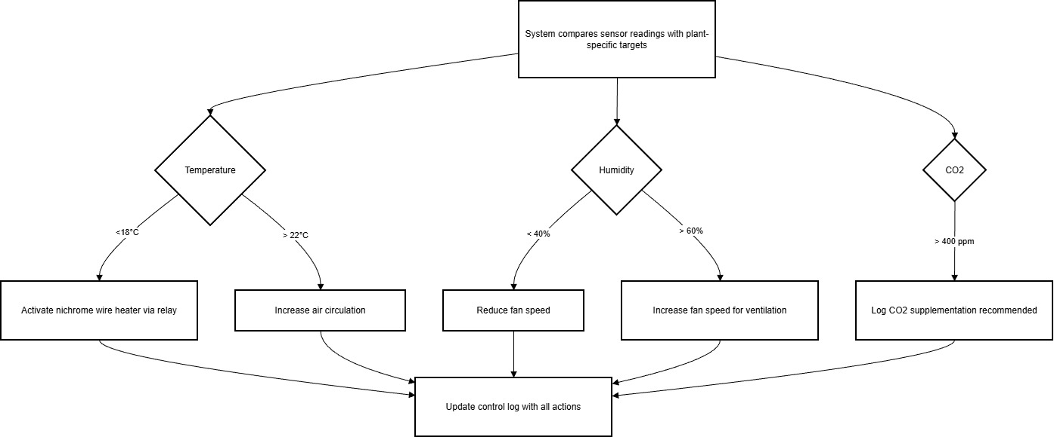

UC-3: Manage Nutrient Delivery System
Row | Actor | Trigger / Condition | Steps / Logic
1 | System | Scheduled cycle (every 30 minutes) | 1. Activate water pump for 5 minutes.  2. Circulate nutrient solution through root zone.  3. Monitor pH during circulation.  4. Log circulation events.
2 | System | Detects pH outside optimal range (5.5 - 6.5) | 1. Calculate correction amount based on current pH, reservoir volume, and target pH.  2. Activate micro-dosing pump (future enhancement).
3 | System | During pH Correction | 3. Add pH Up/Down solution in small increments.  4. Wait 15 minutes, then remeasure pH.  5. Repeat steps until pH is normalized.
4 | System | Scheduled monitoring & estimation | 1. Estimate nutrient depletion based on: days since last change, plant growth stage, and water level changes.
5 | System | Meets alert condition | 2. Alert user when: reservoir is <20% full, 7 days since last nutrient change, or EC levels are out of range (if sensor available).
6 | End User | Manual intervention / adjustment | Alternate Flow:  1. User adds nutrients manually.  2. User logs amount added via app.  3. System recalculates depletion timeline.  Postcondition: Plants receive adequate nutrients at proper pH.

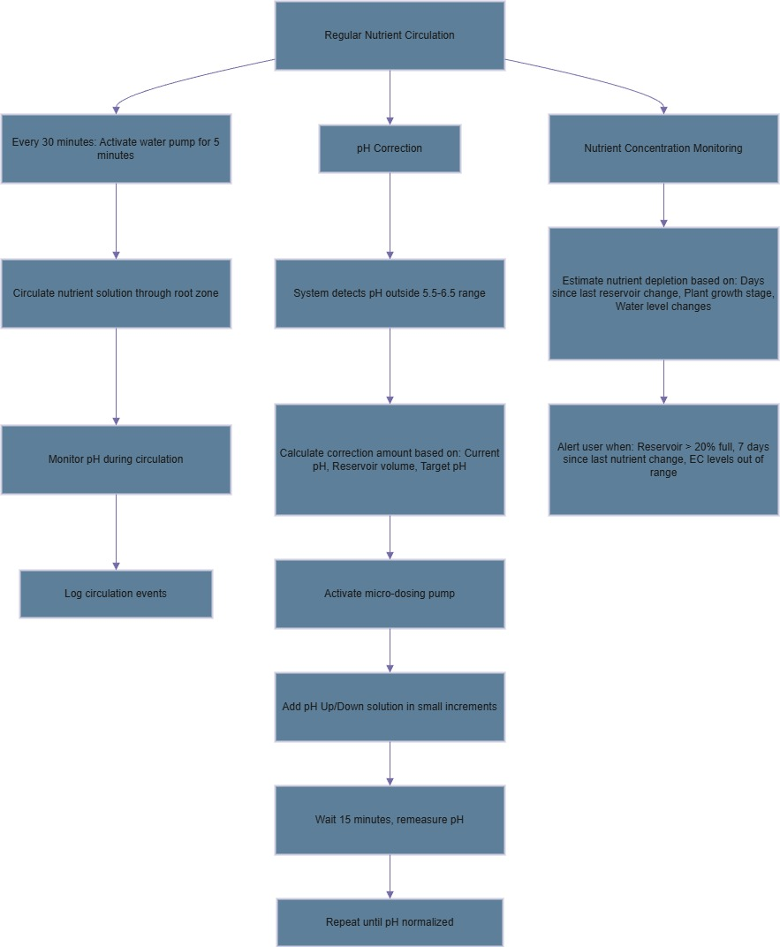

UC-4: Alert User of Issues
Alert Conditions & Categories
Alert Level | Condition / Trigger | Examples
Primary Actor | System
Secondary Actor | End User, Alert System
Critical Alerts | Immediate notification required. | • Water pump failure  • Power outage detected  • Temperature >30°C or <10°C  • Water leak detected (via moisture sensor)
Warning Alerts | Hourly notification if unresolved. | • pH out of range for >2 hours  • Nutrient reservoir <20% full  • Any sensor malfunction  • WiFi connection lost
Informational Alerts | Daily summary notification. | • Daily growth report  • Nutrient depletion estimate  • Water consumption report  • System health status
Notification Methods
Notification Method | Description / Use Case
Mobile App Push Notification | Primary method for all alert levels.
SMS | Used for critical alerts, especially relevant for users in South Africa.
Email Digest | Used for informational alerts and summaries.
Local Buzzer / Indicator | Provides immediate, on-site attention for critical hardware issues.

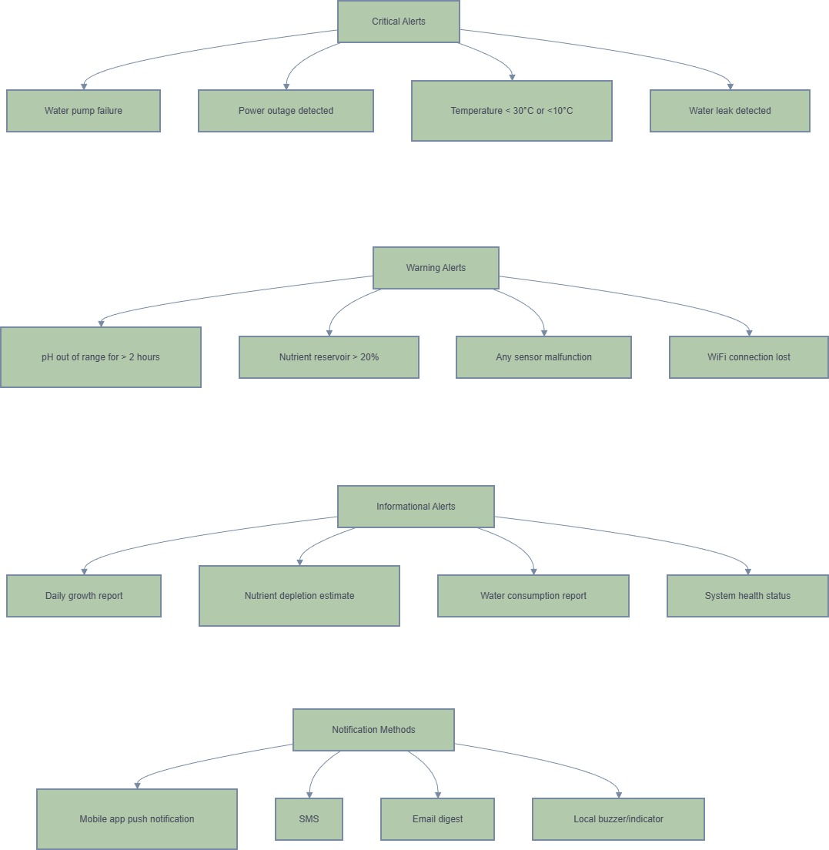

UC-5: Report System Status
Row | Function / Flow | Actor / Trigger | Steps & Details
1 | A. Real-time Dashboard | Primary: Mobile App User / End User  Secondary: Cloud Service  Trigger: User opens app | 1. User opens mobile app or web interface.  2. System displays:  • Current sensor readings (color-coded)  • System status indicators  • Camera feed (future)  • Manual override controls  • Growth progress photos
2 | B. Historical Reports | Trigger: User requests data | 1. User requests historical data.  2. System provides:  • 24-hour parameter graphs  • 7-day trend analysis  • Nutrient consumption charts  • Alert history log
3 | C. Vacation Mode | Trigger: User enables mode | 1. User enables vacation mode.  2. System adjusts to:  • Increase system check frequency  • Send daily status summaries  • Enable extended reservoir capacity logic  • Prioritize critical alerts

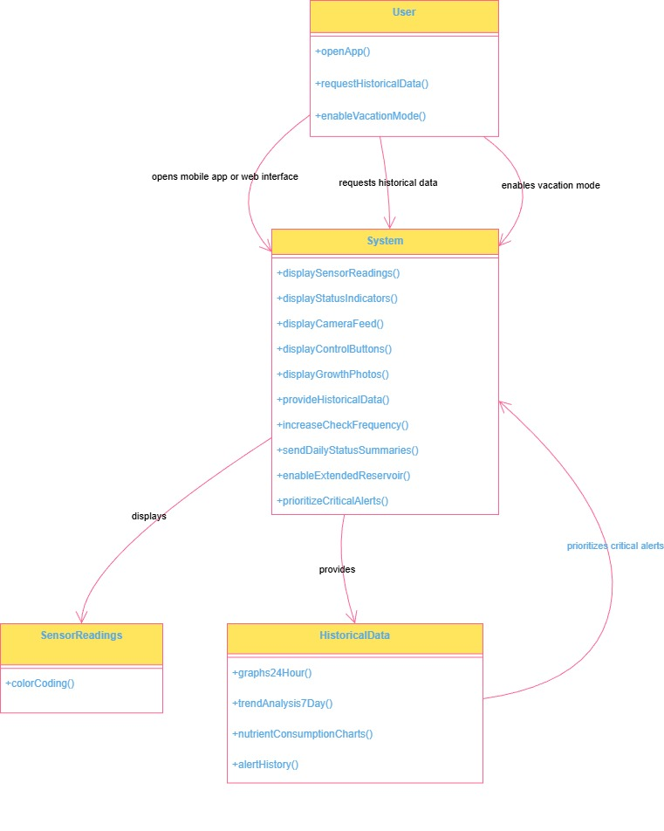

UC-6: Configure Plant-Specific Parameters
Row | Flow / Step | Actor / Condition | Action & Details
1 | Primary Actor & Trigger | Primary Actor: End User  Secondary Actor: Plant Database  Trigger: User begins setup or reconfiguration | (This row sets the context for the use case)
2 | Main Flow: 1. Plant Selection | User selects a plant type from a predefined list. | Options include:  • Lettuce: Temp 18-22°C, pH 5.5-6.0, Light 14-16hrs  • Spinach: Temp 15-20°C, pH 6.0-6.5, Light 12-14hrs  • Kale: Temp 10-25°C, pH 6.0-7.0, Light 14-16hrs  • Herbs (e.g., Basil): Temp 20-25°C, pH 5.5-6.5, Light 16-18hrs
3 | Main Flow: 2. Apply Parameters | System receives the plant type selection. | System automatically applies the optimal parameters for the chosen plant, including:  • Temperature range  • pH range  • Light schedule (for LED control)  • Humidity preferences  • Nutrient schedule
4 | Main Flow: 3. Customization | User reviews the applied settings. | The user has the option to customize any parameter (e.g., temperature, light hours) to override the system's default optimal settings.
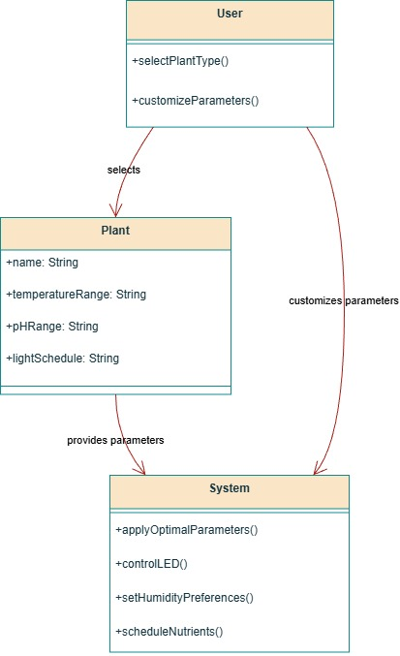

UC-7: Perform System Maintenance
Row | Maintenance Type / Step | Actor / Condition | Actions & Details
1 | Primary Actor & Preconditions | Primary Actor: End User  Preconditions: System alert OR scheduled maintenance trigger | (Context for the maintenance activity)
2 | A. Weekly Maintenance | End User performing routine check | 1. Check and calibrate pH sensor.  2. Clean pump filter.  3. Inspect system for algae growth.  4. Verify all tubing and electrical connections.
3 | B. Bi-weekly Maintenance | End User performing comprehensive refresh | 1. Perform complete nutrient reservoir change.  2. Clean entire system with a mild bleach solution.  3. Inspect and prune plant roots if necessary.  4. Replace any worn components (e.g., filters, tubing).
4 | C1. pH Sensor Calibration | End User ensuring sensor accuracy | Procedure:  1. Prepare pH 4.0 and 7.0 buffer solutions.  2. Follow the sensor manufacturer's specific calibration process.  3. Verify the calibration by testing with the second buffer solution.
5 | C2. Temperature Calibration | End User verifying temperature readings | Procedure:  1. Compare the system's temperature reading with a known, calibrated thermometer.  2. Adjust the sensor's offset in the system settings if a discrepancy is found.

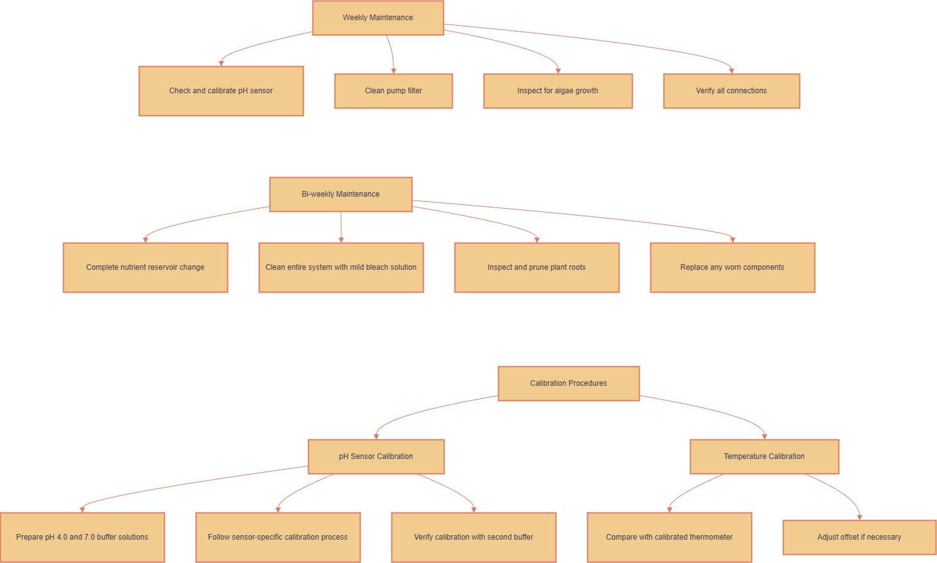

UC-8: Portable Setup & Mobility
Row | Process Phase | Primary Actor / Context | Steps & Details
1 | Context | Primary Actor: End User | (This uses case covers the initial setup and physical relocation of the system.)
2 | Initial Setup | User is preparing the system for first use. | 1. Unfold/carry unit to location (e.g., balcony/kitchen). Max dimensions: 60×40×40cm.  2.Connect the power cable.  3. Fill the reservoir with water.  4. Add nutrient concentrate.  5. Power the system on.  6. Connect to Wi-Fi via the smartphone app.
3 | Relocation | User needs to move the system to a new location. | 1. Drain the reservoir to its minimum level.  2. Power off the system.  3. Carry to new location. Weight when empty: <15kg.  4. Reconnect power.  5. Top up the reservoir with water/nutrients.  6. System resumes normal operation automatically.

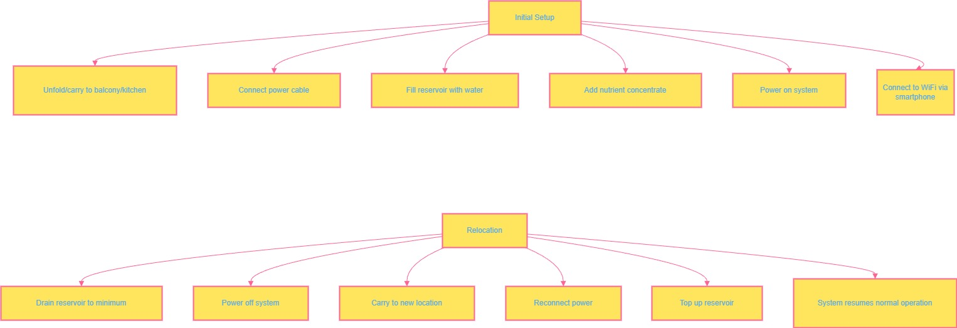

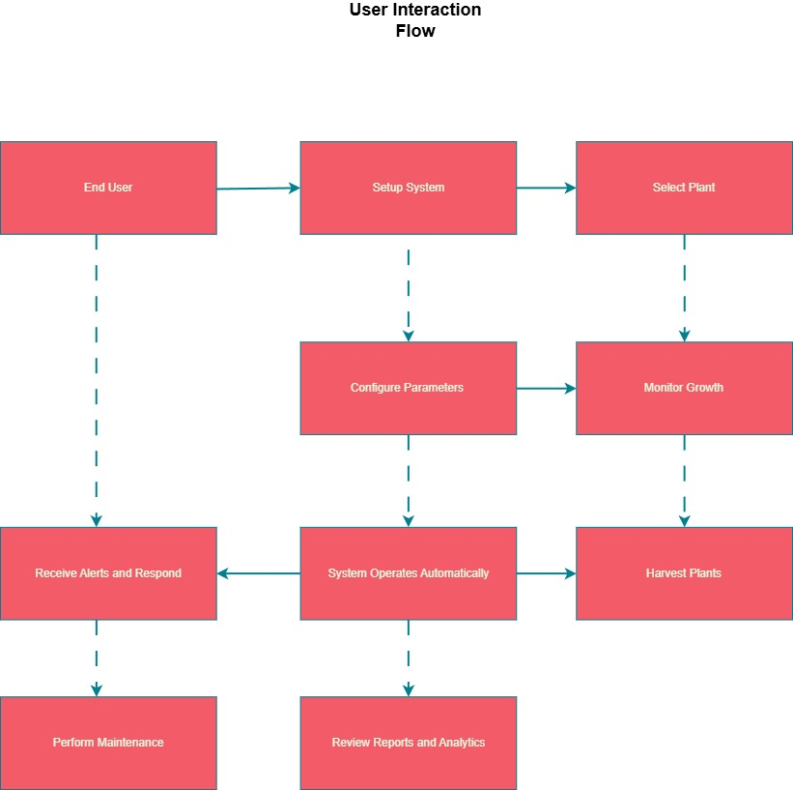

System Component Interactions
SENSORS | ACTUATORS | COMMS | STORANGE | POWER
pH | LED Strips | Wi-Fi | Local Log | 12v Input
Temperature | Water Pump | Bluetooth | Cloud Sync | DC-DC Conv
Humidity | Fan | MQTT | OTA Updates | Backup Battery
CO2 | Heater | HTTP API
Water Level

